**For Loop Over a Function**

A for loop can also be used to execute a function multiple times. For example, below we are executing celsius_to_kelvin three times since there are three items in the iterating list: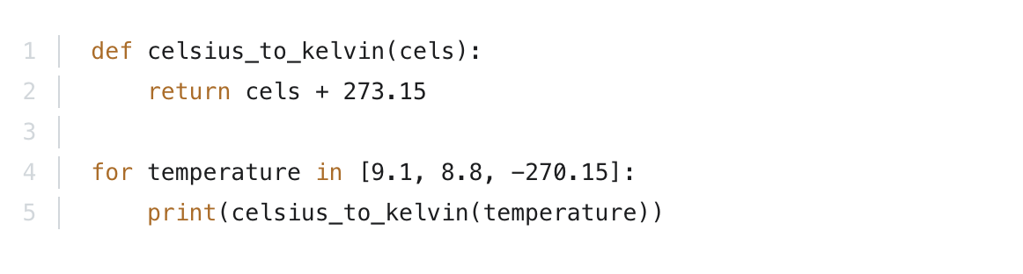

The output of that would be:

282.25  
281.95  
3.0

So, in the first iteration celsius_to_kelvin(9.1) was executed, in the second celsius_to_kelvin(8.8) and in the third celsius_to_kelvin(-270.15).